**United States Department of Agriculture**

**Food and Nutrition Service**

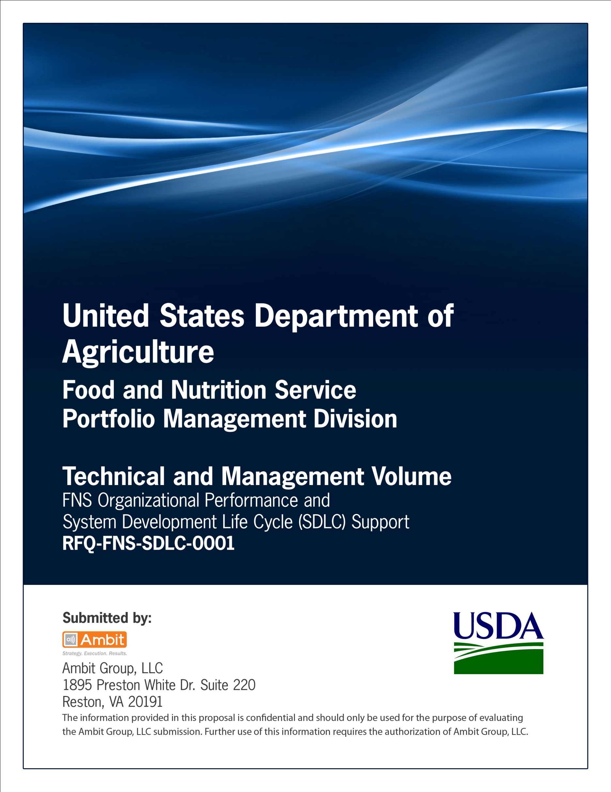

**Office of Information Technology**

**Portfolio Management Division (PMD)**

**FNS Acquisition Plan Template**

**For**

**[System or Project Name]**

**Version 1.1**

September 09, 2013

**Revision History**

|  |  |  |  |
| --- | --- | --- | --- |
| **Version** | **Date** | **Author** | **Change Description** |
| 1.0 | 03-12-2012 | IT Governance Branch (ITGB) | Created/modified the template. |
| 1.1 | 09-09-2013 | IT Governance Branch (ITGB) | Re-formatted the document. |
| 1.2 |  |  |  |
| 1.3 |  |  |  |

**Contact Information**

|  |  |
| --- | --- |
| **Area of Concern** | **Contact Person** |
| IT Governance Lead | Kevin Russ |
| SDLC Coordinator | Syed Jaffery |
| ITIRB Coordinator | Sunny Dilawari |
| Portfolio Management Division Director, Chief Portfolio Officer | Jacqueline Butler |
| Program Management Branch Chief | Allison Willcox |

Contents

Glossary 4

1. Introduction 5

1.1. Organization 5

1.2. Contents of This Document 5

2. Background and Objectives 5

2.1. Statement of Need 5

2.2. Applicable Conditions 5

2.3. Cost 5

2.4. Capability of Performance 5

2.5. Delivery or Performance-Period Requirements 6

2.6. Trade-Offs 6

2.7. Risks 6

2.8. Acquisition Streamlining 6

2.9. Sources 6

2.10. Competition 6

2.11. Source-Selection Procedures 7

2.12. Acquisition Considerations 7

2.13. Budget and Funding 7

2.14. Product and Service Descriptions 8

2.15. Priorities, Allocations, and Allotments 8

2.16. Contractor versus Government Performance 8

2.17. Inherently Governmental Functions 8

2.18. Management Information Requirements 8

2.19. Make or Buy 8

2.20. Test and Evaluation 8

2.21. Logistics Considerations 8

2.22. Government Furnished Property 9

2.23. Government Furnished Information 9

2.24. Environmental and Energy Conservation Objectives 9

3. Milestones for the Acquisition Cycle 10

4. Identification of Participants in Acquisition Plan Preparation 11

Appendix A: References 12

Approvals/Signatures 13

# Glossary

| **Acronym** | **Description** |
| --- | --- |
|  |  |
|  |  |
|  |  |
|  |  |
|  |  |
|  |  |
|  |  |
|  |  |

# Introduction

## Organization

The Food and Nutrition Service (FNS), formerly known as the Food and Consumer Service, administers the nutrition assistance programs of the U.S. Department of Agriculture (USDA). The mission of FNS is to provide children and needy families better access to food and a more healthful diet through its food assistance programs and comprehensive nutrition education efforts.

## Contents of This Document

This acquisition plan provides an overview of the background, assumptions and objectives of this acquisition as well as the specific plan of action for executing the acquisition strategy resulting in the successful award of a performance based contract.

# Background and Objectives

## Statement of Need

Introduce the plan by a brief statement of need. Summarize the technical and contractual history of the acquisition. Discuss feasible acquisition alternatives, the impact of prior acquisitions on those alternatives, and any related in-house effort.

## Applicable Conditions

State all significant conditions affecting the acquisition, such as:

Requirements for compatibility with existing or future systems or programs; and

Any known cost, schedule, and capability or performance constraints.

## Cost

Set forth the established cost goals for the acquisition and the rationale supporting them, and discuss related cost concepts to be employed, including, as appropriate, the following items:

Life-cycle cost. Discuss how life-cycle cost will be considered. If it is not used, explain why. If appropriate, discuss the cost model used to develop life-cycle-cost estimates.

Design-to-cost. Describe the design-to-cost objective(s) and underlying assumptions, including the rationale for quantity, learning-curve, and economic adjustment factors. Describe how objectives are to be applied, tracked, and enforced. Indicate specific related solicitation and contractual requirements to be imposed.

Application of should-cost. Describe the application of should-cost analysis to the acquisition (see [15.407-4](http://www.arnet.gov/far/current/html/Subpart%2015_4.html#wp1208705)).

## Capability of Performance

Specify the required capabilities or performance characteristics of the supplies or the performance standards of the services being acquired and state how they are related to the need.

## Delivery or Performance-Period Requirements

Describe the basis for establishing delivery or performance-period requirements (see [Subpart 11.4](http://www.arnet.gov/far/current/html/Subpart%2011_4.html#wp1077896)). Explain and provide reasons for any urgency if it results in concurrency of development and production or constitutes justification for not providing for full and open competition.

## Trade-Offs

Discuss the expected consequences of trade-offs among the various cost, capability or performance, and schedule goals.

## Risks

Discuss technical, cost, and schedule risks and describe what efforts are planned or underway to reduce risk and the consequences of failure to achieve goals. If concurrency of development and production is planned, discuss its effects on cost and schedule risks.

## Acquisition Streamlining

If specifically designated by the requiring agency as a program subject to acquisition streamlining, discuss plans and procedures to:

Encourage industry participation by using draft solicitations, pre-solicitation conferences, and other means of stimulating industry involvement during design and development in recommending the most appropriate application and tailoring of contract requirements;

Select and tailor only the necessary and cost-effective requirements; and

State the timeframe for identifying which of those specifications and standards, originally provided for guidance only, shall become mandatory.

## Sources

Indicate the prospective sources of supplies or services that can meet the need. Consider required sources of supplies or services (see [Part 8](http://www.arnet.gov/far/current/html/FARTOCP08.html#wp226853)) and sources identifiable through databases including the Government wide database of contracts and other procurement instruments intended for use by multiple agencies. Include consideration of small business, veteran-owned small business, service-disabled veteran-owned small business, HUB Zone small business, small disadvantaged business, and women-owned small business concerns (see [Part 19](http://www.arnet.gov/far/current/html/FARTOCP19.html#wp223561)), and the impact of any bundling that might affect their participation in the acquisition (see [7.107](http://www.arnet.gov/far/current/html/Subpart%207_1.html#wp1098159)) ([15 U.S.C. 644(e)](http://uscode.house.gov/uscode-cgi/fastweb.exe?getdoc+uscview+t13t16+492+90++%2815%29%20%20AND%20%28%2815%29%20ADJ%20USC%29%3ACITE%20%20%20%20%20%20%20%20%20)). When the proposed acquisition strategy involves bundling, identify the incumbent contractors and contracts affected by the bundling. Address the extent and results of the market research and indicate their impact on the various elements of the plan (see [Part 10](http://www.arnet.gov/far/current/html/FARTOCP10.html#wp266706)).

## Competition

Describe how competition will be sought, promoted, and sustained throughout the course of the acquisition. If full and open competition is not contemplated, cite the authority in [6.302](http://www.arnet.gov/far/current/html/Subpart%206_3.html#wp1086852), discuss the basis for the application of that authority, identify the source(s), and discuss why full and open competition cannot be obtained.

Identify the major components or subsystems. Discuss component breakout plans relative to these major components or subsystems. Describe how competition will be sought, promoted, and sustained for these components or subsystems.

Describe how competition will be sought, promoted, and sustained for spares and repair parts. Identify the key logistic milestones, such as technical data delivery schedules and acquisition method coding conferences that affect competition.

When effective subcontract competition is both feasible and desirable, describe how such subcontract competition will be sought, promoted, and sustained throughout the course of the acquisition. Identify any known barriers to increasing subcontract competition and address how to overcome them.

## Source-Selection Procedures

Discuss the source-selection procedures for the acquisition, including the timing for submission and evaluation of proposals, and the relationship of evaluation factors to the attainment of the acquisition objectives (see [Subpart 15.3](http://www.arnet.gov/far/current/html/Subpart%2015_3.html#wp1088864)). When an EVMS is required (see FAR [34.202](http://www.arnet.gov/far/current/html/Subpart%2034_2.html#wp1112574) (a)) and a pre-award IBR is contemplated, the acquisition plan must discuss:

How the pre-award IBR will be considered in the source selection decision;

How it will be conducted in the source selection process (see FAR [15.306](http://www.arnet.gov/far/current/html/Subpart%2015_3.html#wp1088919)); and

Whether offerors will be directly compensated for the costs of participating in a pre-award IBR.

## Acquisition Considerations

For each contract contemplated, discuss contract selection (see [Part 16](http://www.arnet.gov/far/current/html/FARTOCP16.html#wp226194)); use of multiyear contracting, options, or other special contracting methods (see [Part 17](http://www.arnet.gov/far/current/html/FARTOCP17.html#wp223561)); any special clauses, special solicitation provisions, or FAR deviations required (see [Subpart 1.4](http://www.arnet.gov/far/current/html/Subpart%201_4.html#wp1044104)); whether sealed bidding or negotiation will be used and why; whether equipment will be acquired by lease or purchase (see [Subpart 7.4](http://www.arnet.gov/far/current/html/Subpart%207_4.html#wp1084017)) and why; and any other contracting considerations. Provide rationale if a performance-based acquisition will not be used or if a performance-based acquisition for services is contemplated on other than a firm-fixed-price basis ((see [37.102](http://www.arnet.gov/far/current/html/Subpart%2037_1.html#wp1082895)(a), [16.103](http://www.arnet.gov/far/current/html/Subpart%2016_1.html#wp1085506)(d), and [16.505](http://www.arnet.gov/far/current/html/Subpart%2016_5.html#wp1093205)(a)(3)).

For each order contemplated, discuss:

* For information technology acquisitions, how the capital planning and investment control requirements of [40 U.S.C. 11312](http://uscode.house.gov/uscode-cgi/fastweb.exe?getdoc+uscview+t37t40+1574+51++%2840%29%20%20AND%20%28%2840%29%20ADJ%20USC%29%3ACITE%20%20%20%20%20%20%20%20%20) and OMB Circular A-130 will be met (see [7.103](http://www.arnet.gov/far/current/html/Subpart%207_1.html#wp1098057)(t) and [Part 39](http://www.arnet.gov/far/current/html/FARTOCP39.html#wp223485)); and
* Why this action benefits the Government, such as when—
  + The agency can accomplish its mission more efficiently and effectively (e.g., take advantage of the servicing agency’s specialized expertise; or gain access to contractors with needed expertise); or
  + Ordering through an indefinite delivery contract facilitates access to small business concerns, including small disadvantaged business concerns, 8(a) contractors, women-owned small business concerns, HUBZone small business concerns, veteran-owned small business concerns, or service-disabled veteran-owned small business concerns.

## Budget and Funding

Include budget estimates, explain how they were derived, and discuss the schedule for obtaining adequate funds at the time they are required (see [Subpart 32.7](http://www.arnet.gov/far/current/html/Subpart%2032_7.html#wp1028592)).

## Product and Service Descriptions

Explain the choice of product or service description types (including performance-based acquisition descriptions) to be used in the acquisition.

## Priorities, Allocations, and Allotments

When urgency of the requirement dictates a particularly short delivery or performance schedule, certain priorities may apply. If so, specify the method for obtaining and using priorities, allocations, and allotments, and the reasons for them (see [Subpart 11.6](http://www.arnet.gov/far/current/html/Subpart%2011_6.html#wp1081639)).

## Contractor versus Government Performance

Address the consideration given to OMB Circular No. A-76 (see [Subpart 7.3](http://www.arnet.gov/far/current/html/Subpart%207_3.html#wp1091459)).

## Inherently Governmental Functions

Address the consideration given to [Subpart 7.5](http://www.arnet.gov/far/current/html/Subpart%207_5.html#wp1078196).

## Management Information Requirements

Discuss, as appropriate, what management system will be used by the Government to monitor the contractor’s effort. If an Earned Value Management System is to be used, discuss the methodology the Government will employ to analyze and use the earned value data to assess and monitor contract performance. In addition, discuss how the offeror/contractor EVMS will be verified for compliance with the American National Standards Institute/Electronics Industries Alliance (ANSI/EIA) Standard-748, Earned Value Management Systems, and the timing and conduct of integrated baseline reviews (whether prior to or post award). (See [34.202](http://www.arnet.gov/far/current/html/Subpart%2034_2.html#wp1112574).)

## Make or Buy

Discuss any consideration given to make-or-buy programs (see [15.407-2](http://www.arnet.gov/far/current/html/Subpart%2015_4.html#wp1208671)).

## Test and Evaluation

To the extent applicable, describe the test program of the contractor and the Government. Describe the test program for each major phase of a major system acquisition. If concurrency is planned, discuss the extent of testing to be accomplished before production release.

## Logistics Considerations

Describe:

The assumptions determining contractor or agency support, both initially and over the life of the acquisition, including consideration of contractor or agency maintenance and servicing (see [Subpart 7.3](http://www.arnet.gov/far/current/html/Subpart%207_3.html#wp1091459)), support for contracts to be performed in a designated operational area or supporting a diplomatic or consular mission (see [25.301-3](http://www.arnet.gov/far/current/html/Subpart%2025_3.html#wp1080227)); and distribution of commercial items;

The reliability, maintainability, and quality assurance requirements, including any planned use of warranties (see [Part 46](http://www.arnet.gov/far/current/html/FARTOCP46.html#wp226846));

The requirements for contractor data (including repurchase data) and data rights, their estimated cost, and the use to be made of the data (see [Part 27](http://www.arnet.gov/far/current/html/FARTOCP27.html#wp224991)); and

Standardization concepts, including the necessity to designate, in accordance with agency procedures, technical equipment as “standard” so that future purchases of the equipment can be made from the same manufacturing source.

## Government Furnished Property

Indicate any Government property to be furnished to contractors, and discuss any associated considerations, such as its availability or the schedule for its acquisition (see [45.102](http://www.arnet.gov/far/current/html/Subpart%2045_1.html#wp1023556)).

## Government Furnished Information

Discuss any Government information, such as manuals, drawings, and test data, to be provided to prospective offerors and contractors. Indicate which information that requires additional controls to monitor access and distribution (e.g., technical specifications, maps, building designs, schedules, etc.), as determined by the agency, is to be posted via the Federal Technical Data Solution (FedTeDS) (see [5.102](http://www.arnet.gov/far/current/html/Subpart%205_1.html#wp1098039)(a)).

## Environmental and Energy Conservation Objectives

Discuss all applicable environmental and energy conservation objectives associated with the acquisition (see [Part 23](http://www.arnet.gov/far/current/html/FARTOCP23.html#wp227606)), the applicability of an environmental assessment or environmental impact statement, the proposed resolution of environmental issues, and any environmentally-related requirements to be included in solicitations and contracts.

**Security Considerations**

For acquisitions dealing with classified matters, discuss how adequate security will be established, maintained, and monitored (see [Subpart 4.4](http://www.arnet.gov/far/current/html/Subpart%204_4.html#wp1082414)). For information technology acquisitions, discuss how agency information security requirements will be met. For acquisitions requiring routine contractor physical access to a Federally-controlled facility and/or routine access to a Federally-controlled information system, discuss how agency requirements for personal identity verification of contractors will be met (see [Subpart 4.13](http://www.arnet.gov/far/current/html/Subpart%204_13.html#wp1074116)).

**Contract Administration**

Describe how the contract will be administered. In contracts for services, include how inspection and acceptance corresponding to the work statement’s performance criteria will be enforced.

**Other Considerations**

**Standardization Concepts**

**The Industrial Readiness Program**

**The Defense Production Act**

**The Occupational Safety and Health Act**

**Support Anti-Terrorism/Effective Technologies**

Support Anti-terroism by fostering Effective Technologies by Act of 2002 (SAFETY Act) (see [Subpart 50.2](http://www.arnet.gov/far/current/html/Subpart%2050_2.html#wp1077774));

**Foreign Sales Implications**

**Special Requirements**

Special requirements for contracts to be performed in a designated operational area or supporting a diplomatic or consular mission; and

**Any Other Matters Germane to the Plan Not Covered Elsewhere**

# Milestones for the Acquisition Cycle

Address the following milestones and any others as appropriate.

|  |  |  |
| --- | --- | --- |
| **Milestone** | **Planned Completion** | **Actual Completion** |
| Acquisition Plan Approval |  |  |
| Statement of Work |  |  |
| Specifications |  |  |
| Data Requirements |  |  |
| Acquisition-Package Preparation |  |  |
| Purchase Request |  |  |
| Issuance Of Synopsis |  |  |
| Issuance of Solicitation |  |  |
| Evaluation of Proposals, Audits, and Field Reports |  |  |
| Beginning and Completion of Negotiations |  |  |
| Contract Preparation, Review, and Clearance |  |  |
| Contract Award |  |  |

# Identification of Participants in Acquisition Plan Preparation

List the individuals who participated in preparing the acquisition plan, giving contact information for each.

# 

# Appendix A: References

Insert the name, version number, description, and physical location of any documents referenced in this document. Add rows to the table as necessary.

The following table summarizes the documents referenced in this document.

|  |  |  |
| --- | --- | --- |
| **Document Name** | **Description** | **Location** |
| Document Name and Version Number | Document description | URL or Network path where document is located |
|  |  |  |
|  |  |  |

# Approvals/Signatures

The undersigned acknowledge that they have reviewed the [name of document] document and agree with the information presented within this document. Changes to this document will be coordinated with, and approved by, the undersigned, or their designated representatives.

|  |  |  |  |
| --- | --- | --- | --- |
| Signature: |  | Date: |  |
| Print Name: |  |  |  |
| Title: |  |  |  |
| Role: | [Project or System Name] Project Manager |  |  |
|  |  |  |  |
| Signature: |  | Date: |  |
| Print Name: |  |  |  |
| Title: |  |  |  |
| Role: | [Project or System Name] Business Owner |  |  |
|  |  |  |  |
| Signature: |  | Date: |  |
| Print Name: |  |  |  |
| Title: |  |  |  |
| Role: | Organization’s Approving Authority |  |  |